PROVINGS—Will Taylor, MD 2001

Hahnemann's Contributions to the Healing Arts
Hahnemann's contributions to the development of a rational basis for healing are many. He was an early voice in disfavor of bloodletting as a routine adjunctive treatment. He was early among his colleagues in appreciating the infectious and contagious character of many diseases, and in drafting hygienic recommendations for these. His aphorisms 210-230 are an effective argument dismantling the Cartesian mind-body dichotomy that haunts conventional medicine, as well as many alternative approaches, to this day.
Although the observation of cure by similars predated him by at least 2,000 years, Hahnemann uniquely based a systematic and robust methodology of assessment and cure on this principle. And in large part, this latter was made possible by one of his greatest contributions to medicine - the systematic exploration of that thing which a cure by similars demands be similar to disease - the effect of medicinal substances on the healthy organism.

Hahnemann's Times
The medicine of Hahnemann's day relied on an awkward collection of rationales for its recommended therapeutics. Bloodletting, purging, cathartic and diaphoretic treatments, all were rationalized as necessary to balance theorized humors and eliminate theorized toxins from the body. Botanicals and heavy metals such as mercury were used in formulary combinations often better known to the apothecaries than to the prescribing physician, which did not permit accurate reflection on the curative effects of individual constituents.
Medicinal properties were often attributed to superficial features of a substance, hiding true explanation behind a smokescreen of supposed understanding. When one of the foremost physicians of Europe - William Cullen - published his pharmacology text in 1790, he attributed the curative effect of Peruvian Bark (Cinchona) in intermittent fevers to the simplistic, superficial observation that it was a bitter and astringent substance.
[Modern-day conventional medicine may look on such rationalizations humorously in its hubris, but it is instructive to ask how many depressed patients - treated with "selective serotonin reuptake inhibitors" - have had the serotonin levels in their brains measured or monitored. The answer should be obvious.]

Cinchona - the First Self-Proving
Hahnemann was, among many things, a chemist. He was also a master of many languages, and in the course of translating Cullen's work into German, he reflected that he could name at least a dozen things that were as bitter and astringent as the bark of the Peruvian Cinchonatree, which had no effect on intermittent fever.
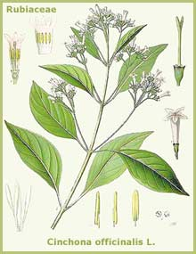He determined to experiment on himself with this substance, and in doing so, brought out upon himself the characteristic symptoms of intermittent fever - a syndrome which Cinchona was often seen to cure.
Hahnemann's Cinchona proving was remarkable for several reasons. It brought to full meaning Hippocrates' observation that "that which may poison, may also heal."
It suggested that we could functionally describe disease in terms of its carefully observed visible signs and symptoms, rather than labor at proposing a description of the invisible disturbance of the interior of the organism.
Finally, it provided a model for a method of systematically ascertaining the medicinal properties of a substance.
This may not seem remarkable to us today, in an era of investigational pharmacology and clinical trials, but it is important to recognize that Hahnemann's "provings" (Ger: experiments) were the first systematic drug trials performed in the history of Western medicine.
In 1798, eight years after his Cinchona self-proving, Hahnemann went public with his new ideas on medical assessment and cure, with the publication of his "Essay on a New Principal for Ascertaining the Curative Power of Drugs".
Seven years later, in 1805, he published his first collection of remedy provings, "Fragmenta de viribus medicamentorum positivis sive in sano corpore observatis" (Fragments on the Positive Powers of Drugs, - that is to say, their effects observed in the healthy body). This contained the pathogenic symptoms of 27 substances, which JH Clarke later described as "the first effort towards the reconstruction of the Materia Medica on a rational basis of pure experiment on the healthy human body."

Refining the Process of Proving
Hahnemann collected pathogenic symptoms from a variety of sources. As the science and art of homeopathy grew under his care, he refined his notion of what constituted the most useful and reliable ways of bringing out proving symptoms. Early provings were dominated by the use of crude, toxic or near-toxic doses, from both intentional and accidental exposures.
Hahnemann did not need to look far for "accidental" provings of such remedies as the Arsenicum and Mercurius salts, or botanicals such as Jalapa or Belladonna. These substances were widely used in old-school medicine, and we have only to reflect on such comments as Benjamin Rush's shouts to a street crowd of Philadelphia during a cholera epidemic, "give them all calomel - give them calomel until they drool" to harvest proving symptoms of Mercurius dulcis(Mouth-salivation: Merc-d[2] ).

A New Rationale
- not a New Pharmacopoeia
Many of Hahnemann's early remedies were substances in use by the old-school medicine of his day; his contribution was not a new pharmacopoeia, but a new rationale for the use of existing medicinal substances, based on the symptoms brought out in the healthy.
In The Medicine of Experience (1806), Hahnemann recommended "to ascertain the effects of the medicinal agents, we must give only one pretty strong dose to the temperate healthy ... when the action of the first dose is fully over, a similar or even a stronger portion ... For medicines that are weaker we require ... a considerable dose ..."
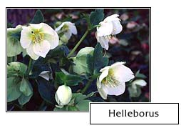In a letter in the Neues Archiv. (1813), he gave Stapf directions for the proving of Helleborus: "Add a drop of the tincture to eight ounces of water and one drachm of alcohol; shake well, and take an ounce every hour and a half or two hours until some decided effects are produced."
These crude-dose provings often included exposures to substances that may not appear to shine of scientific sophistication, but they do bring an element of humanity and humor to our practice.

Among the provers of the following compounds, we have:
- Cuprum:
(must be read with a British accent)
A lady, aet. 67, her daughter, aet. 39, a maidservant, aet. 22, ate a fricassée of fowls that had been cooked in a badly-tinned copper pan
[Hughes, Cyclopaedia of Drug Pathogenesy]
- 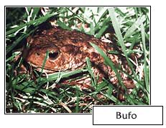Latrodectus mactans:
September 4, 1853 I was called to see Mr. D. at Old Point, who had been bitten by a small, black spider on the prepuce, whilst on the privy seat at 12.30 O'clock.
[Dr. Samuel. A. Jones; Homeopathic Recorder, July, 1889]
- Bufo:
Effects of a toad jumping into the mouth and entering the stomach during sleep [in TF Allen]

The Proving of Sepia
Ernest Farrington chronicled for us the fortuitous initial proving of Sepia, in his Clinical Materia Medica:
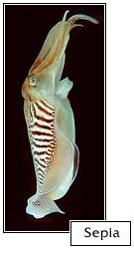
"It is stated on the authority of Dr. Hering that an intimate friend and patient of Hahnemann, an artist, was in the habit of wetting his brush, containing India ink, with his saliva. Failing to cure him of his chronic ailments, Hahnemann suggested the ink as the probable cause of his persistent symptoms.
The artist doubted this, but nevertheless modified his custom by covering the lips with a thin layer of sponge moistened with water, the mouth being protected by an impervious though pliable shield, and his obscure illness shortly passed away. Hahnemann then instituted provings with the Sepiae succus."

Hahnemann Publishes His Provings
Hahnemann published the volumes and editions of his Reine Arzneimittellehre (Materia Medica Pura) between 1820-1827. Included are the provings of 62 remedies, with expanded provings of many from his Fragmenta.
Details of how the provings were performed are not available, but in addition to the toxicological symptoms included and documented as such, Dunham suggests "From the few glimpses we get here and there it seems probable that insoluble substances were proved in the first trituration, and vegetable drugs in the mother tincture - repeated small doses being taken until some effect was produced."
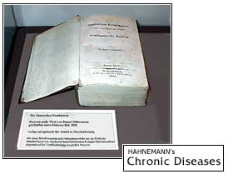By the time of the publication of his Chronic Diseases
(1828-1839), with 30+ years of experience under his belt, and the intervening discovery of potentization, Hahnemann advocated provings in potency rather than crude dose. Regarding his 1830 proving of Natrum muriaticum in the 30C potency, he related "it is only in such a highly potentized form that this and all other drugs display the whole of their power to alter the condition of the organism."
28 new remedies were introduced with provings in Chronic Diseases, with expanded provings of 19 previously-introduced. Including those provings published in Stapf's Archives, Hahnemann left us eventually with approximately 100 remedies well- or partially-proved.
In the 5th and 6th editions of the Organon (Dudgeon's translation) Hahnemann observes:
"The most recent experience has taught that medicinal substances, when taken in the crude state, do not for a long time display the full extent of their virtues, as they do when taken in higher developments.
Thus any one, even of those medicines whose virtues are considered weakest, is now found to be most advantageously studied if four to six globules of the thirtieth dilution be taken every morning for several days."
Dunham elaborates on the issue of potency and dose in provings in The Science of Therapeutics, suggesting "In order to obtain an exhaustive proving ... we must prove the drug both in dilutions and in massive doses."
Provings in crude dose and in higher potency bring out the full range of a remedy's actions on the organism, offering complementary aspects of the potential of a remedy to cure. This can be readily seen where we have adequate provings across the ranges of potency.
For example, compare the pathogeneses of Latrodectus mactans (the North American Black Widow spider) in the Homeopathic Recorder, July, 1889 by Samuel. A. Jones (reprinted in Anshutz, New, Old and Forgotten Remedies) which is based on toxicological observation of accidental bites, to the provings done at the 200x and 500x potencies by the Hering Proving Committee (Pacific Coast Journal of Homoeopathy, 1933; reprinted in O.Julian, Materia Medica of New Homeopathic Remedies.)
In this comparision we see that the crude doses tend to bring out more obviously the gross pathologies and organ/tissue affinities of remedies - but they lack the refinement of sensations, modalities and mental/emotional symptoms provided by provings at higher potency.

Other Historical Provings
Hahnemann's provers' group provided us with a large number of remedy provings, but there have been other highly productive proving groups as well. Johann Christian Gottfried Jorg, an "old-school" physician in Leipsic during Hahnemann's tenure at the University, instituted a number of provings with the express purpose of disproving the principle of similars.
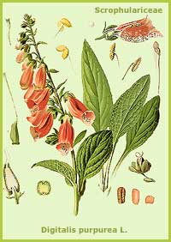His provers' group conducted provings of 15 remedies, including Arnica, Laurocerasus, Opium, Digitalis and Valerian, which Hahnemann subsequently adopted as some of the most thorough and productive provings in his collection - clearly supporting, and not discrediting, the practice of homeopathy. These were published by Jorg in 1825, in his Materialien zu einer kunftigen Heilmittellehre durch Versuche des Arzneyen an gesunden Menschen.
Between 1842 and 1848, the Austrian Provers' Union conducted a series of re-provings of remedies introduced by Hahnemann, which generally supported, and in many cases extended our knowledge of these remedies. Most of these provings were done in both crude and potentized doses.

The Advantage of Self-Proving
In his essay The Medical Observer, Hahnemann suggested "The best opportunity for exercising and perfecting our observing faculty is afforded by instituting experiments with medicines upon ourselves."
Provings not only add to homeopathy's library of materia medica, they may also provide the individual prover with a window of direct personal experience into the pathology they'll be facing in the clinic. Many of the bearers of our homeopathic heritage held an intimate knowledge of their remedial substances, born in this way.

Remedies from Latin America and Pennsylvania
Homeopathy entered a Tubercular period [Mind - restless, Mind - travel, desire for] following Hering's graduation from Leipzig, with his excursion to Surinam and subsequently to Pennsylvania.
Extending beyond the medicaments of "old-school" medicine and the medicines of the European botanical traditions, Hering introduced native substances of South America and the Carribean, including Lachesis, Theridion (the orange widow spider of the island of Uraçoa), and plants such as Jatropha.
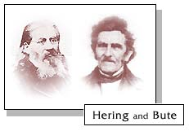His friend and student George Henry Bute returned to Pennsylvania from Surinam, and proved the local Sanguinaria (bloodroot) so prevalent in the Pennsylvania spring-time woods. Hering followed Bute to Pennsylvania "where the land is like Germany and the people are free."
There he proved the local Mountain Laurel (Kalmia), the venom of the Eastern Timber Rattler (Crotalus horridus), and over 70 other remedies including many indigenous species of northeastern North America.
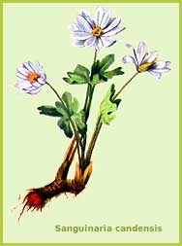In addition to supervising most of his provings at the 30C potency, Hering did self-provings on a good number of these remedies by drinking the washings of his mortar from the third trituration.
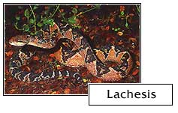

A Colorful Proving Team
One of the most colorful teams of provers in our heritage is that of Edwin Moses Hale and William Burt. Both graduates of the Cleveland Homeopathic College in the late 1850's, Hale became interested in the remedies claimed for successful cures in the Eclectic and Native American botanical traditions. It was his belief that all such cures were attributable to the action of similars, whether intended to be or not:
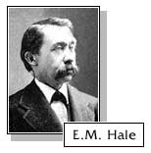"Our course, as consistent homoeopathicians, is, to CLAIM ALL CURES AS MADE BY THE LAW OF SIMILIA, AND PROVE THEM TO BE SUCH, as did Hahnemann.
"The law discovered by our great master is all embracing, universal, and the sooner his followers adopt this proposition, the better it will be for the honor and influence of our school."
- EM Hale
Special Symptomatology of the New Remedies
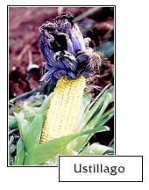
William Burt was responsible for the actual proving of many of these remedies - as many as 30, generally proven in crude dose as "heroic" provings
Burt's provings include:
Aesculus, Baptisia, Cactus grandiflorus, Caulophyllum, Collinsonia, Dioscorea, Hamamelis, Hydrastis canadensis, Iris versicolor, Leptandra virginica, Phytolacca, Pulsatilla nutalliana (the native Pulsatilla of northwestern North America), Ustillago and Veratrum viride (North America's native Veratrum specie).
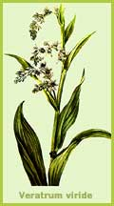We owe a tremendous debt of gratitude to the named and unnamed provers over history who have provided us with their direct experiences of the properties of our materia medica. By following in their footsteps, our knowledge of the true curative properties of substances will continue to grow to meet the needs of all suffering humanity.

Where to Find Historical Provings:
Samuel Hahnemann, Materia Medica Pura
Samuel Hahnemann, Chronic Diseases
Edwin Moses Hale, Special Symptomatology of the New Remedies
Timothy Field Allen, Encyclopedia of Pure Materia Medica (including most of the 3 sources above)
O. Julian, Materia Medica of New Homeopathic Remedies

